# PIZZA SALES SQL LITE QUERIES

## **KPI’s**

1. **Total Revenue:**

SELECT

    SUM(TOTAL_PRICE) AS TOTAL_REVENUE

FROM

    PIZZA_SALES;



1. **Average Order Value:**

SELECT

    SUM(total_price) / COUNT(DISTINCT ORDER_ID) AS avg_order_value

FROM

    pizza_sales;



1. **Total Pizza Sold:**

SELECT

    SUM(QUANTITY) AS TOTAL_PIZZA_SOLD

FROM

    PIZZA_SALES;



1. **Total Orders:**

SELECT

    COUNT(DISTINCT ORDER_ID) AS TOTAL_ORDERS

FROM

    PIZZA_SALES;

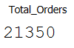

1. **Average Pizzas Per Order:**

SELECT

    ROUND(SUM(QUANTITY) * 1.0 / COUNT(DISTINCT ORDER_ID),

          2) AS AVG_PIZZAS_PER_ORDER

FROM

    PIZZA_SALES;

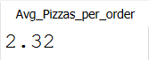

## **B. Daily Trend for Total Orders**

SELECT

    CASE STRFTIME('%w', ORDER_DATE)

        WHEN '0' THEN

            'Sunday'

        WHEN '1' THEN

            'Monday'

        WHEN '2' THEN

            'Tuesday'

        WHEN '3' THEN

            'Wednesday'

        WHEN '4' THEN

            'Thursday'

        WHEN '5' THEN

            'Friday'

        WHEN '6' THEN

            'Saturday'

    END                      AS WEEK_DAY,

    COUNT(DISTINCT ORDER_ID) AS TOTAL_ORDERS

FROM

    PIZZA_SALES

GROUP BY

    STRFTIME('%w', ORDER_DATE)

ORDER BY

    TOTAL_ORDERS DESC;

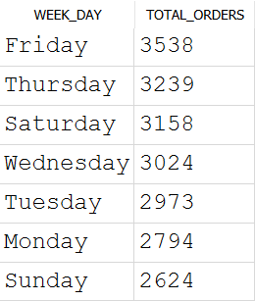

## **Hourly Trend for Orders:**

SELECT

    STRFTIME('%H', ORDER_TIME) AS ORDER_HOURS,

    COUNT(DISTINCT ORDER_ID)   AS TOTAL_ORDERS

FROM

    PIZZA_SALES

GROUP BY

    STRFTIME('%H', ORDER_TIME)

ORDER BY

    TOTAL_ORDERS DESC;

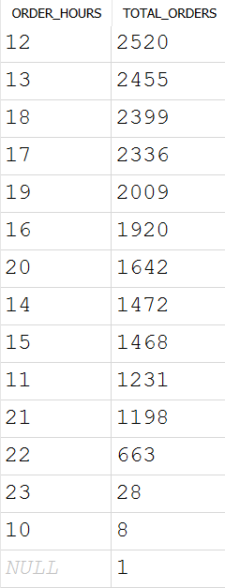

## **D. % of Sales by Pizza Category:**

SELECT

    PIZZA_CATEGORY,

    ROUND(

        SUM(TOTAL_PRICE),

        2

    )        AS TOTAL_PRICE,

    ROUND(SUM(TOTAL_PRICE) * 100 /(

        SELECT

            SUM(TOTAL_PRICE)

        FROM

            PIZZA_SALES

    ),

          2) AS PCT

FROM

    PIZZA_SALES

GROUP BY

    PIZZA_CATEGORY:  
 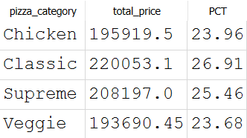

## **E. % of Sales by Pizza Size:**

WITH TOTAL_SALES AS (

    SELECT

        SUM(TOTAL_PRICE) AS GRAND_TOTAL

    FROM

        PIZZA_SALES

)

SELECT

    PIZZA_SIZE,

    ROUND(

        SUM(TOTAL_PRICE),

        2

    )        AS TOTAL_PRICE,

    ROUND(SUM(TOTAL_PRICE) * 100 / GRAND_TOTAL,

          2) AS PCT

FROM

    PIZZA_SALES,

    TOTAL_SALES

GROUP BY

    PIZZA_SIZE;

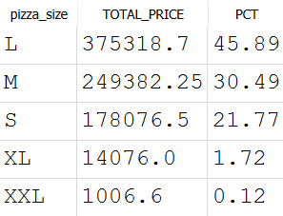

## **F. Total Pizzas Sold by Pizza Category For February:**

SELECT

    PIZZA_CATEGORY,

    SUM(QUANTITY) AS TOTAL_PIZZA_QUANTITY

FROM

    PIZZA_SALES

WHERE

    STRFTIME('%m', ORDER_DATE) = '02'

GROUP BY

    PIZZA_CATEGORY;

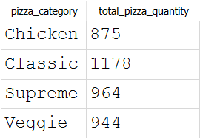

## **G. Top 5 Best Sellers by Total Pizzas Sold:**

SELECT

    pizza_name,

    sum(quantity) as total_pizza_sold

FROM

    pizza_sales

GROUP BY

    pizza_name

ORDER BY

    total_pizza_sold DESC

LIMIT 5;

